Let’s remember
Name: .......................................................................... Class: …………………
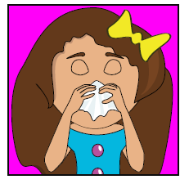  I‘ve got a ………………………………… . | 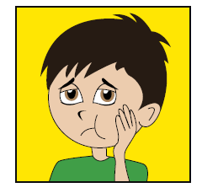  I‘ve got a ………………………………… .
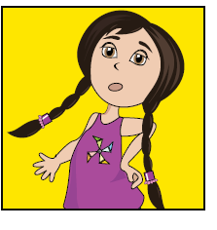  I ………………………………………………… . | 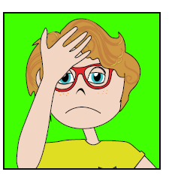  I‘ve got a ………………………………… .
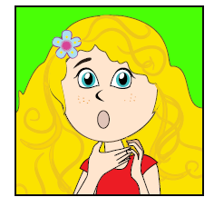  I‘ve ……………………………………………… . | 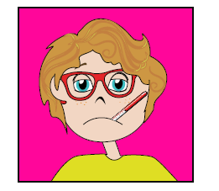  I ………………………………………………… .
- Complete the sentences? (Pupil’s Book p.29)

- Use the phrases and make sentences using should or shouldn’t.
We should ……… We shouldn’t..........
  - go swimming

  - eat chips

  - drink milk

  - smoke

  - eat vegetables

  - do sports

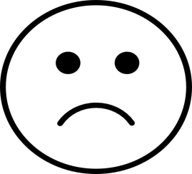
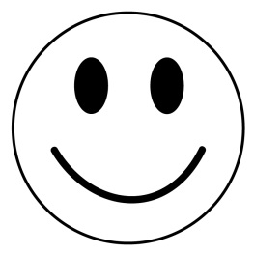
- Write the words in the right box (nice, cunning, dangerous, clever, selfish, generous, lazy, kind, rude, friendly)
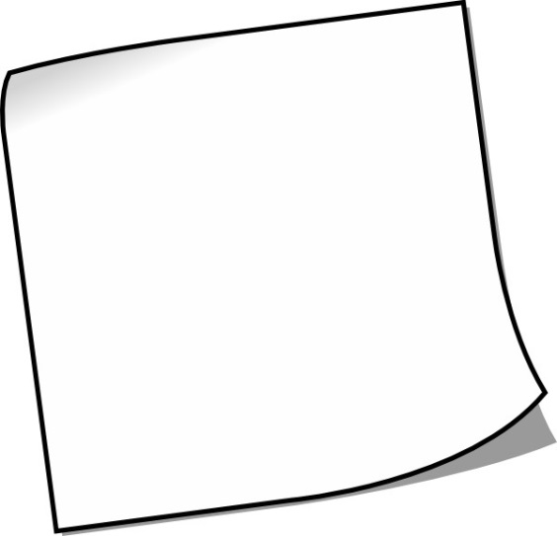

- Look at the animals. Compare using the words big, short, tall, small, fat

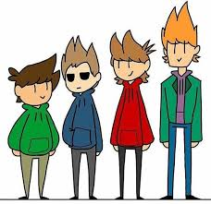
- The last boy is …………………………
………………………………… boy.

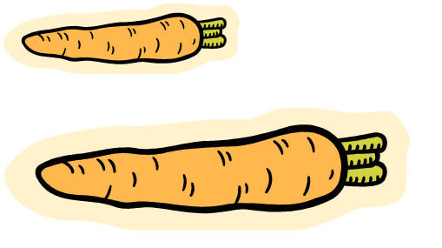
- The first carrot is ………………………
…………………………………the second carrot.
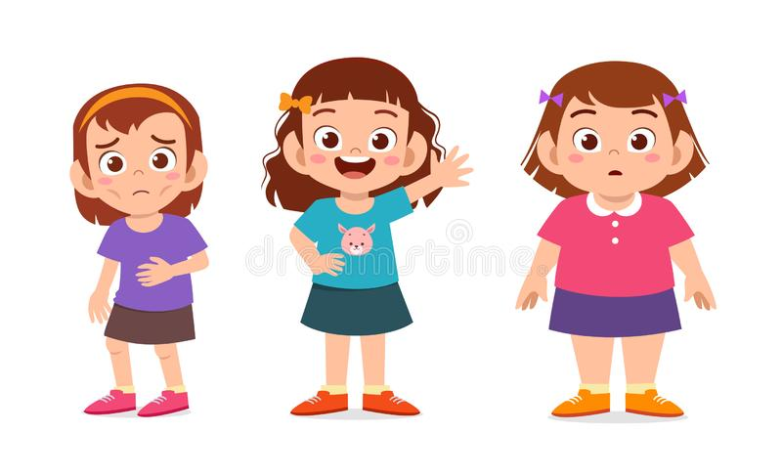

- The third girl is ………………… …………………………………. girl.

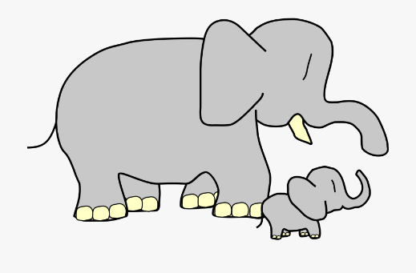
- Mummy elephant is ………………………
………………………………… baby elephant.
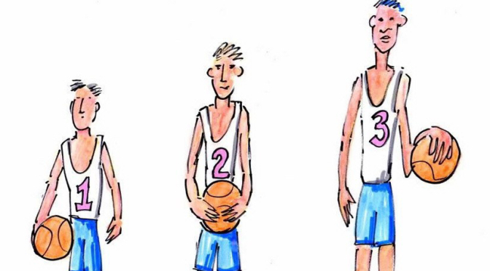
The first boy ……………………………………………………………………………… boy.

- Put the words in the right order.
  - any / sugar / table / on / there / isn’t / the
……………………………………………………………………………………………………………………
  - are / there / vegetables / some / basket / the / in
………………………………………………………………………………………………………………………
  - olives / any / pizza / there / on / aren’t / this
.............................................................................................................................
  - some / lemonade / fridge / there / in / is / the
………………………………………………………………………………………………………………………

- Complete using the words ( eggs, butter, milk, salt, put, whisk, toast)

Scrambled eggs on toast
Crack the ………………….. in a bowl. ………………. the eggs well. Melt the ………………………… in a frying pan. ……………. the eggs and the …………………. in the frying pan. Keep stirring. Add ……………………. and pepper. After two minutes, put the scrambled eggs on your ……………….! Breakfast is ready!

